NMOS with Load

Question 1

For the circuit below (enhancement Load Inverter), assume these parameters,
MOSFET process parameter for M_{L} is K’_{L}= 5 μA/V², (W/L)L = 2 and threshold voltage, V_{TNL} = 0.7V. MOSFET process parameter for M_{X} is K’_{D}= 25 μA/V², (W/L)D = 4 and threshold voltage, V_{TND} = 0.7V.

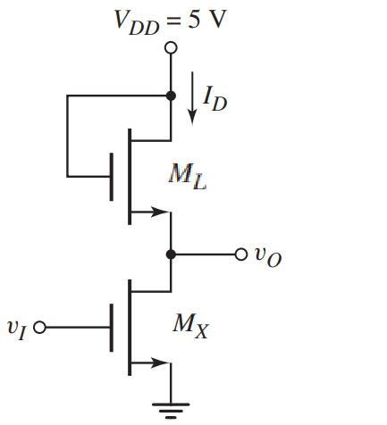

(a) | Assume V_{I} = 5 V. Find value of Vo in volt. Find I_{D} and Power Dissipation.  Verify the operating mode of M_{L} and M_{X}.
(b) | What should be the value of V_{I} if we want M_{L} to operate in the triode region?
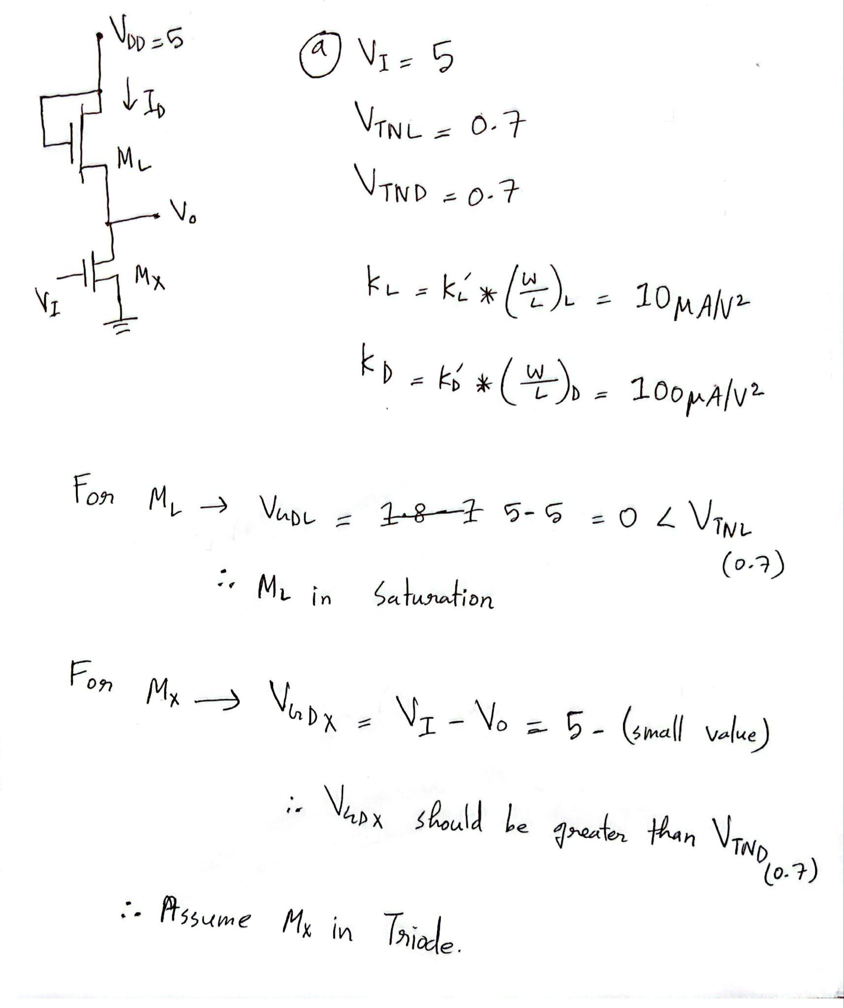
Solution:

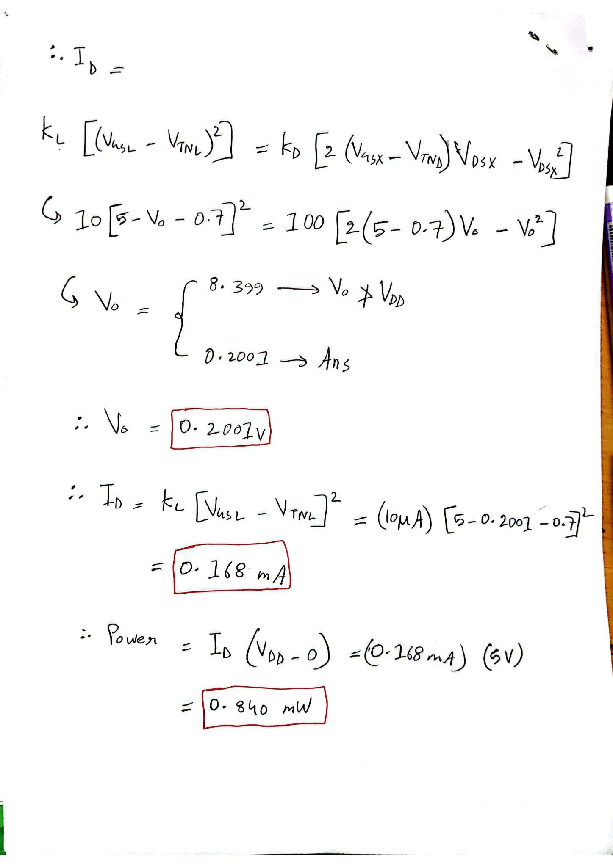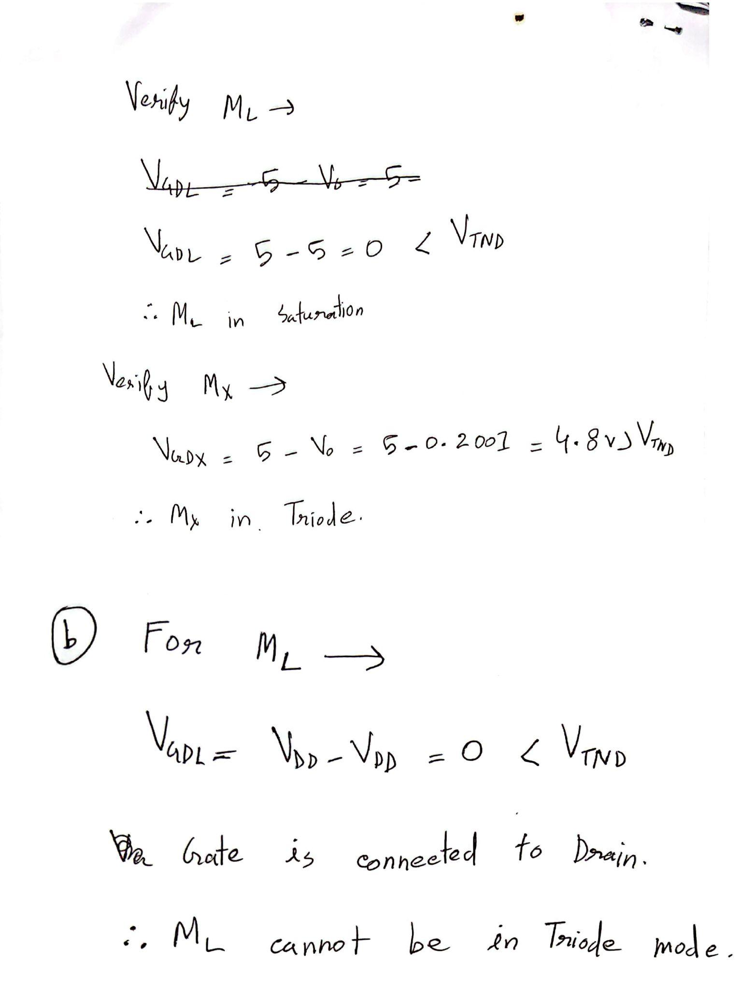

Question 2

For the circuit below (Depletion Load NOR), assume these parameters,
MOSFET process parameter for M_{L} is K’_{L}= 50 μA/V², (W/L)L = 2 and threshold voltage, V_{TNL} = −0.6V. MOSFET process parameter for both M_{X} and M_{Y} is K’_{D}= 33.25 μA/V², (W/L)D = 4 and threshold voltage, V_{TND} = 0.4V.

(a) | Assume V_{X} = V_{Y} = 1.8 V. Find value of Vo in volt. Find I_{DX}, I_{DY}, I_{DL} and Power Dissipation. Verify the operating mode of M_{L}.
(b) | Now, assume V_{X} = V_{Y} = 0.1 V. Find value of Vo, I_{DX}, I_{DY}, I_{DL}.
(c) | What should be the operating mode of MX and MY if V_{X} = 1.8V and V_{Y} = 0 V?  (Use logical reasoning, no need for calculation)

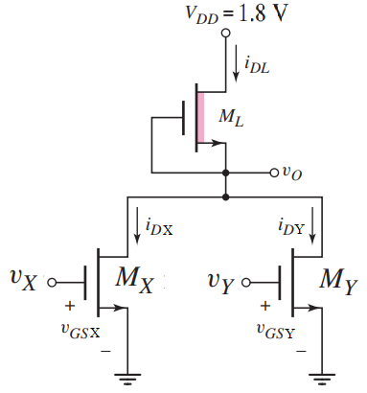

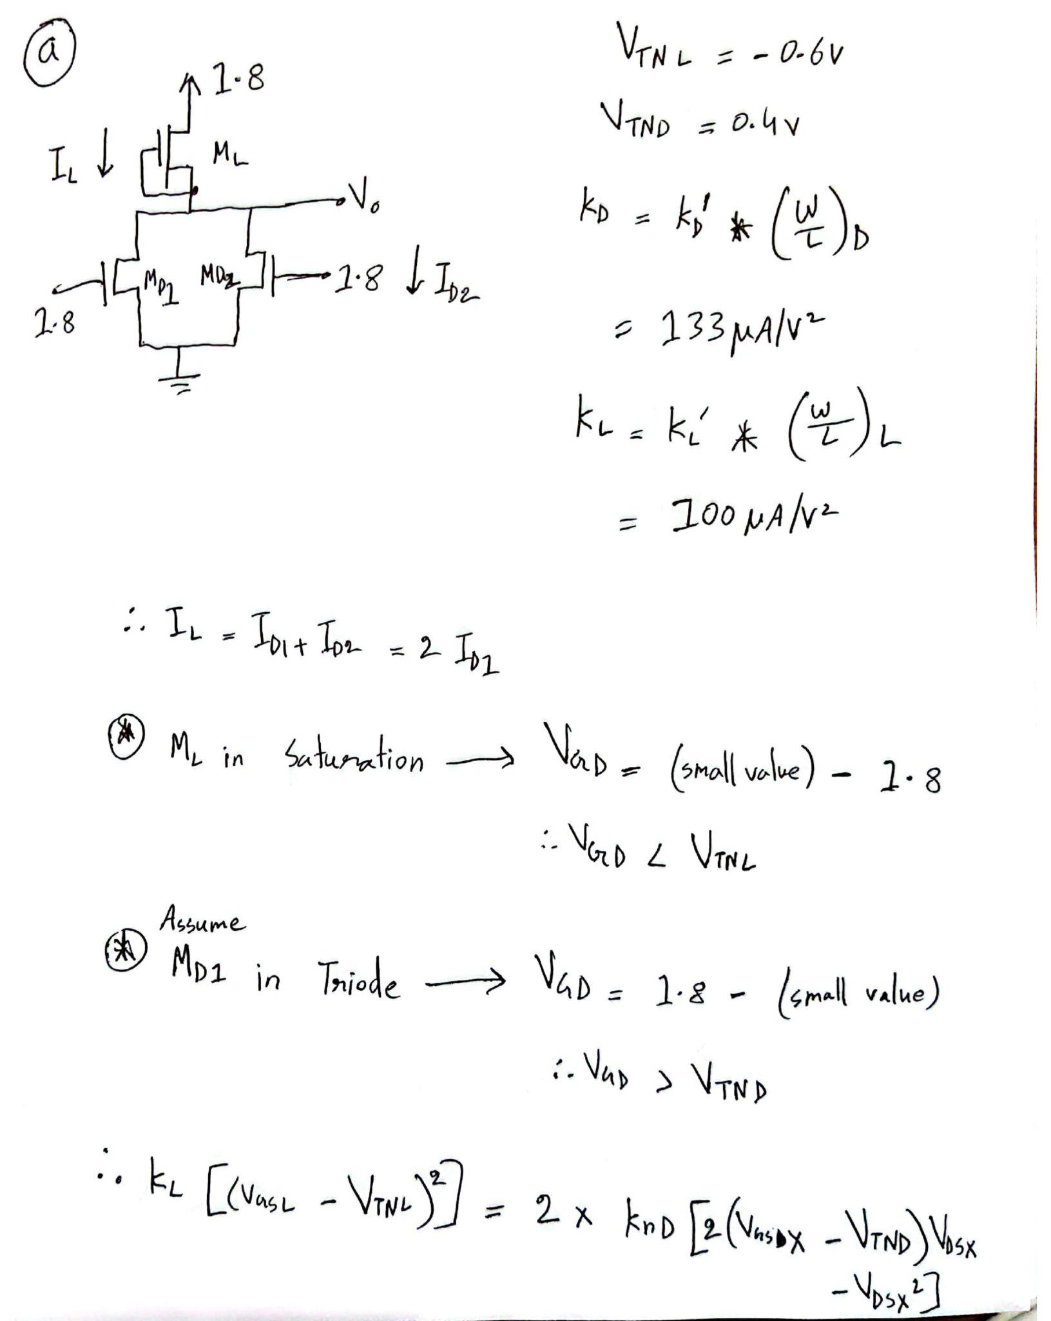
Solution:
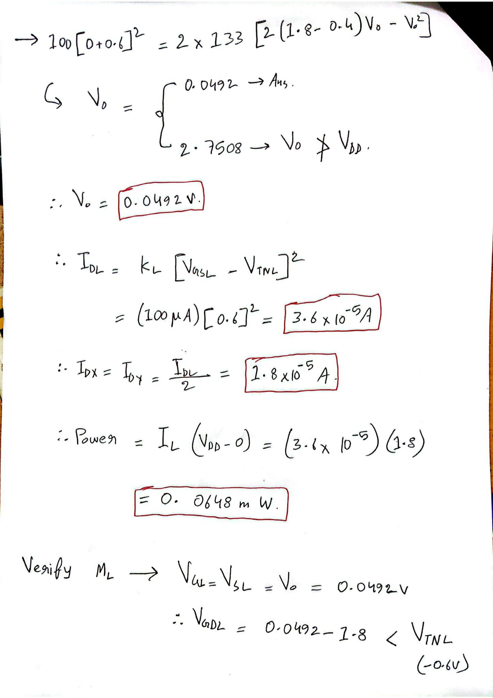

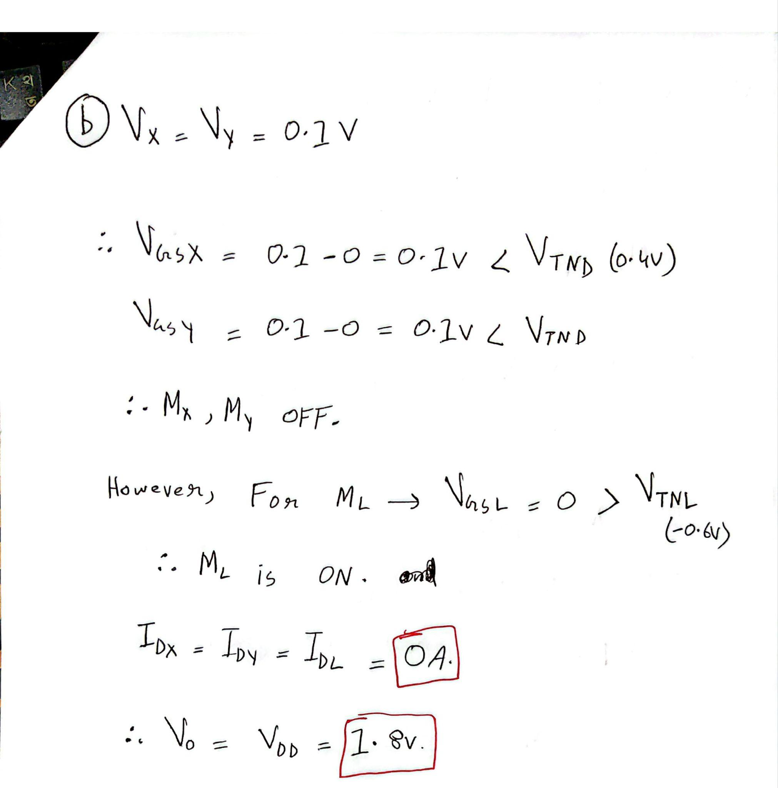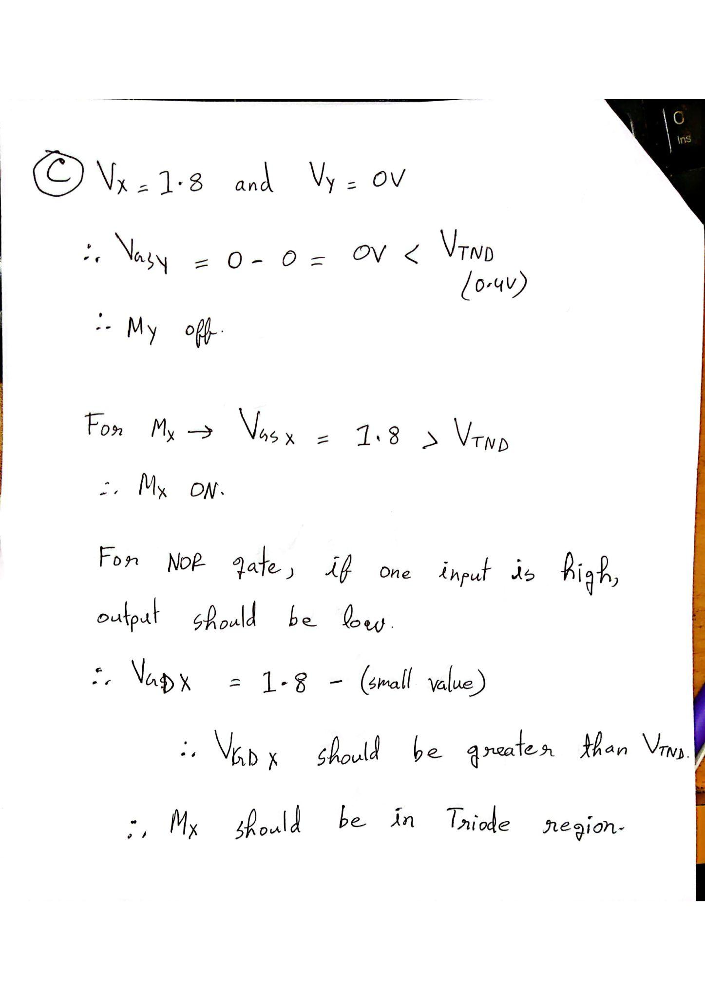

Question 3
The enhancement-load NMOS NOR gate in the figure is biased at V_{DD} = 5.5 V. The transistor parameters are K_{n} = 0.2mA/V² , V_{TN1} = 0.4 V, V_{TN2} = 1 V, V_{TN L} = 0.9 V.
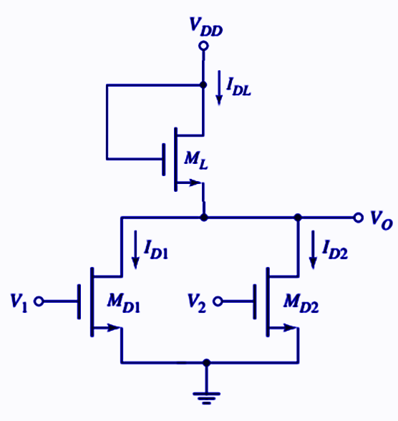

(a) | Find the operating mode of the load NMOS transistor.
(b) | Find the value of v_{o} in V and I_{DL,} I_{D1,} I_{D2} in mA for v_{I}= 5.5V, v₂= 5.5V
(c) | Find the operating mode of the transistor M_{D1}.

Solution:
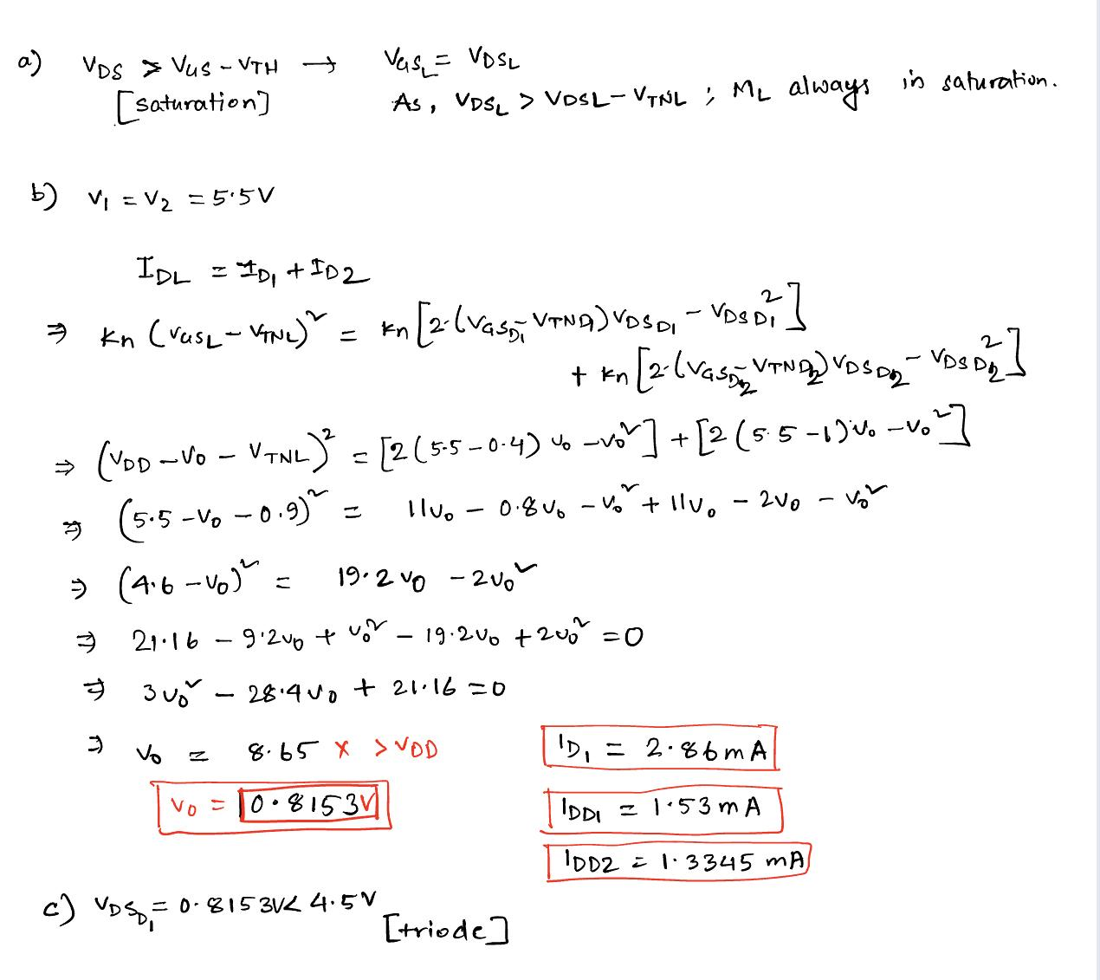

CMOS Logic

Question 4

(a) | Design a static CMOS logic circuit that implements the logic function Y= (AB+C)D
(b) | Design a static CMOS logic circuit that implements the logic function Y= (A+B)CD
(c) | Design a static CMOS logic circuit that implements the logic function Y= F(AB+C(D+E))

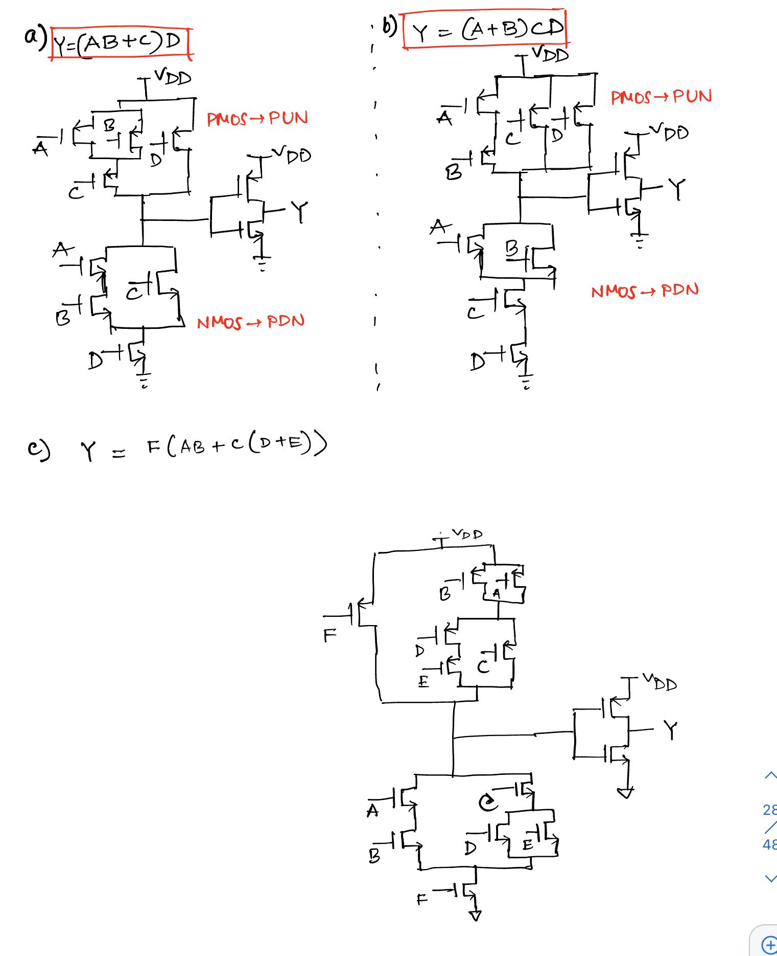
Solution:

Question 5
Design a CMOS logic circuit to implement the given compound gate in Figure below. First derive the logical expression of output Y and then design the CMOS network.

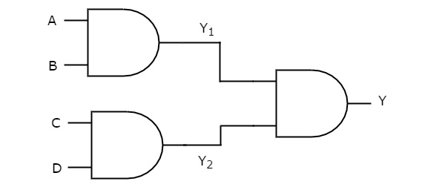

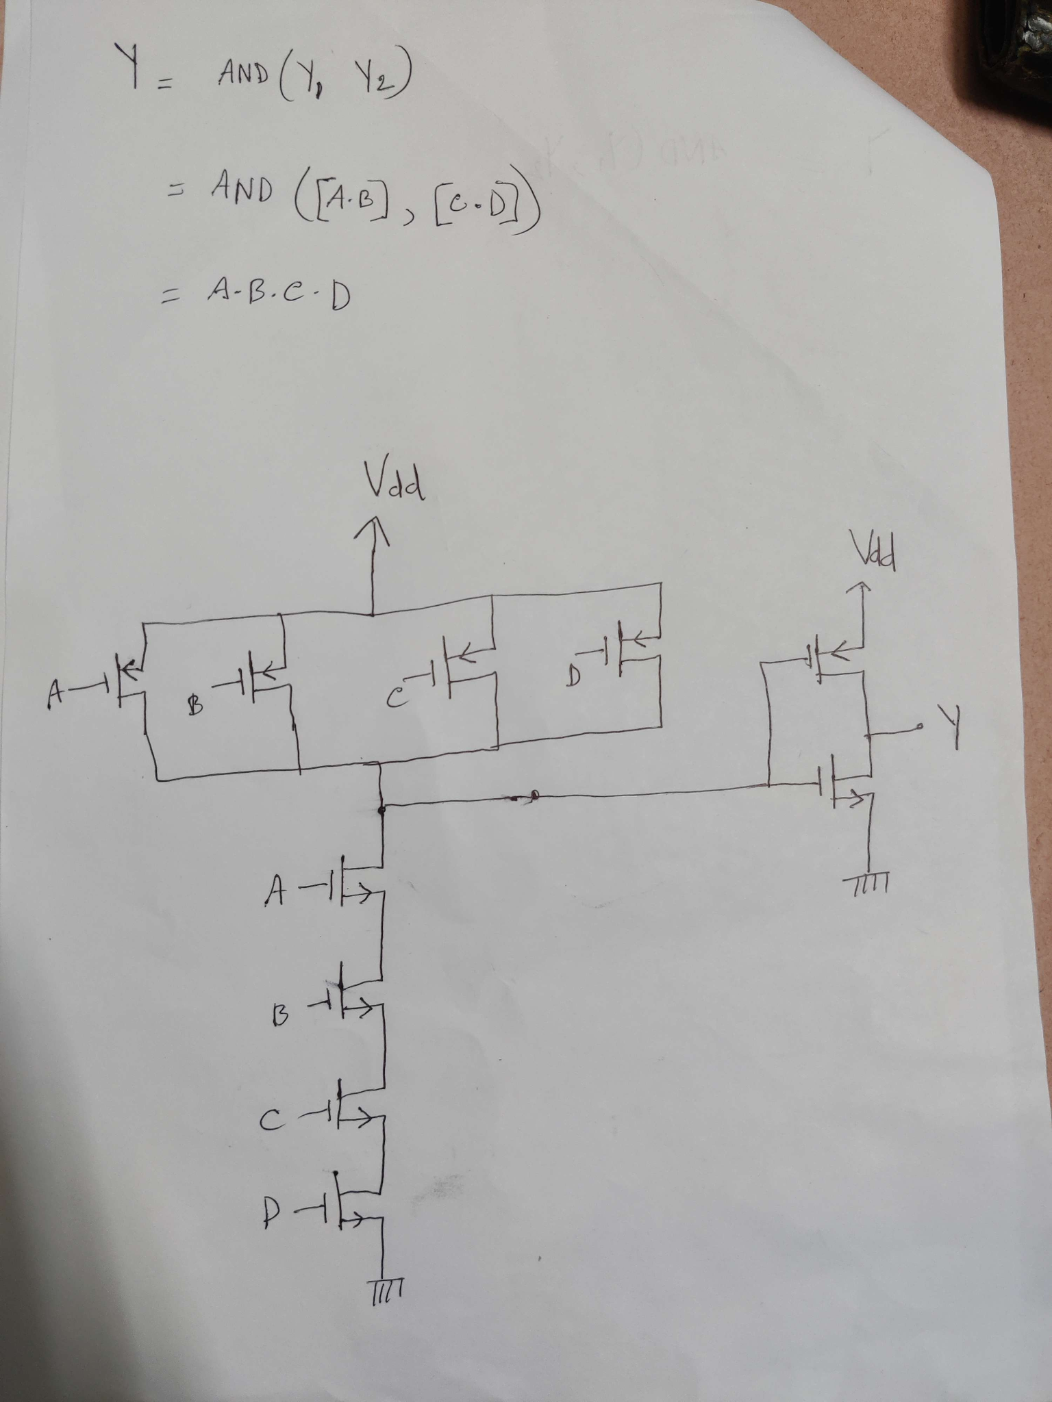
Solution:

